Alabama State Level Repository
Retrieval of CMS Registration ID

To sign onto the State Level Repository (SLR), providers will need their NPI and CMS Registration ID.
The CMS Registration ID is associated with their registration at the National Registration and Attestation (NLR).

BY PHONE
The CMS registration ID can be obtained by calling the CMS Help Desk. Providers will need their NPI and the last 5 digits of the Tax ID associated with the registration. The CMS Help Desk can be reached at 866.484.8049, option #1 or TTY 866.523.4759. Hours are Monday -Friday, 7am – 7pm et.

VIA WEBSITE
Step One: Log into your NLR account using your National Plan and Provider Enumeration System (NPPES) user ID and password. The NLR link is: https://ehrincentives.cms.gov/hitech/login.action. | Step Two: Navigate to the Status Tab.
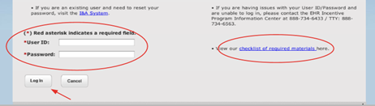 | 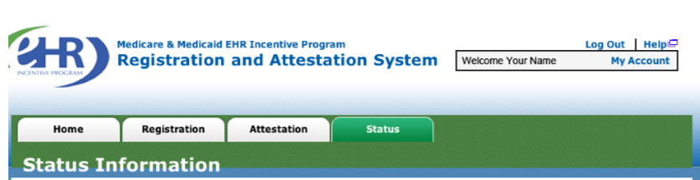

Step Three: Your CMS registration ID will be displayed. Confirm the NPI associated with the registration ID as these will be your SLR log-in credentials.
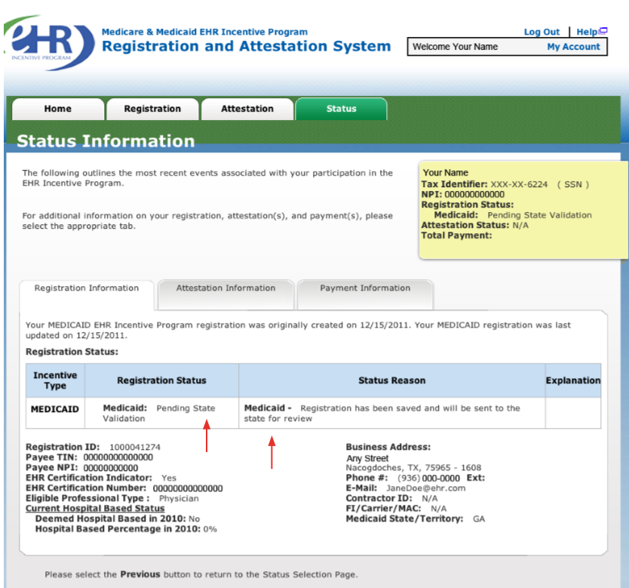

Step Four: If you do not make any changes, hit logout. If changes are made, then hit resubmit and then logout.

